High-Level Data Link Control (HDLC)

Bit Oriented approach

1. It simply views the frame as a collection of bits.
2. Bit oriented protocol: HDLC (High level data link control)
   1. The Synchronous DataLink Control (SDLC) protocol developed by IBM is an example of a bit oriented protocol
   2. SDLC was later standardized by the ISO as the High Level Data Link Control (HDLC) protocol
   3. Bit oriented protocol
   4. HDLC frame format:
      1. 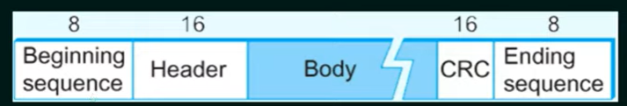
      2. Beginning and ending sequence: 01111110 → This sequence is also transmitted during any times that the link is idle so that the sender and receiver can keep their clocks synchronized.
      3. Header: Address and control field
      4. Body: Payload (Variable size)
      5. CRC: Cyclic redundancy check - error detection
   5. Types of HDLC Frames:
      1. The type of frame is determined by the **control field (in header)**:
         1. I-frame: 1st bit is 0 (will carry the information)
         2. S-frame: 1st two bits is 10: error control and flow control
         3. U-frame: 1st two bits is 11: like link management